Problem 1:

Create an HBase table named 'clicks' with a column family 'hits' such that it should be able to

store last 5 values of qualifiers inside 'hits' column family.

create 'clicks','hits'

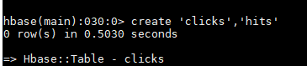

* Insert data using Put command:

put 'clicks','83.1.67.309','hits:google','5'

put 'clicks','83.1.67.309','hits:yahoo','6'

put 'clicks','83.1.67.309','hits:facebook','7'

put 'clicks','83.1.67.309','hits:gmail','0'

put 'clicks','83.1.67.309','hits:instagram','1'

* Insert data using pig:

raw_data= load 'ipdata.txt' using PigStorage(',') as (ip:chararray, google:int, yahoo:int, facebook:int,gmail:int,instagram:int);

dump raw_data

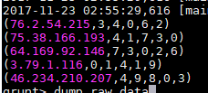

STORE raw_data INTO ' hbase://clicks' USING org.apache.pig.backend.hadoop.hbase.HBaseStorage( 'hits:google

hits:yahoo

hits:facebook

hits:gmail

hits:instagram'

);

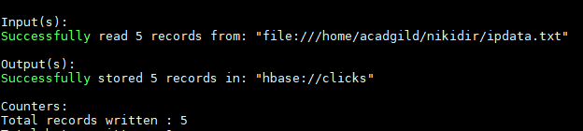

Some of the records inserted:

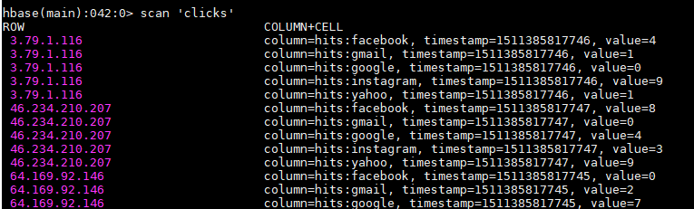

Problem 2:

Add few records in the table and update some of them. Use IP Address as row-key. Scan the

table to view if all the previous versions are getting displayed.

Alter schema to have 5 version. By default its 1.

alter 'clicks', NAME => 'hits', VERSIONS => 5

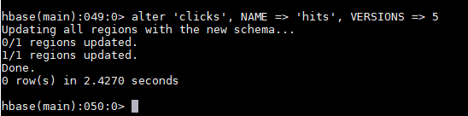

Change value of goggle column which was ‘0’ before

put 'clicks','3.79.1.116','hits:google','3'

* With get

get 'clicks','3.79.1.116',{COLUMN=>'hits:google',VERSIONS => 4}

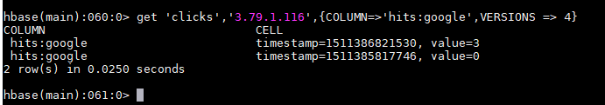

* With scan:

scan 'clicks', {VERSIONS=>4}

